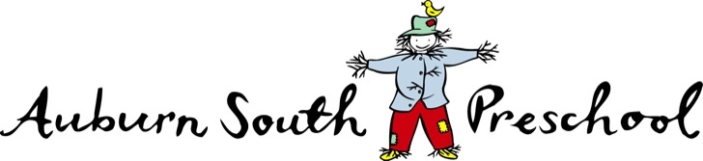

2022 Session Times

Auburn South Preschool provides sessions for both 3 and 4 year old programs:

- 3 year old Funded groups: Joey (Blue) and Puggle (Yellow) – 8 hours (funding of 5 hours provided in 2022)

- 4 year old Funded groups: Kangaroo (Red), Dingo (Green) and Bilby (Purple) – 16 hours (funded at 15 hours)

Sunflower Room | Monday | Tuesday | Wednesday | Thursday | Friday
Morning | Dingo  8.30 - 3.00 | Dingo  8.30 - 3.00 | Dingo  8.30- 11.30 | Joey  8.30 – 12.30 | Puggle  8.30 – 1.30
Afternoon |  |  | Joey  12.30 - 4.30 | Puggle  1.15 – 4.15

Banksia Room | Monday | Tuesday | Wednesday | Thursday | Friday
Morning | Kangaroo  8.45 – 3.15 | Kangaroo  8.45 - 3.15 | Kangaroo  8.45 -11.45 | Bilby  8.45-3.15 | Bilby  8.45 - 3.15
Afternoon |  |  | Bilby  12.45 – 3.45

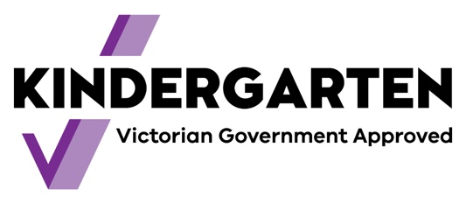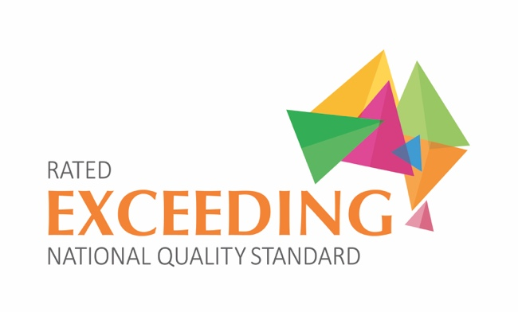

PROPOSED FEE SCHEDULE 2022 –
3 YEAR OLD & 4 YEAR OLD PROGRAMS
(Program costs are currently under review and may be subject to change)

 | 3 Y.O.  Funded programs  8 hour programs | 4 Y.O.  Funded programs  16 hour programs | Families Eligible for the Kindergarten Fee Subsidy (Concession) | Fees Payable By
 | Blue & Yellow  (5 hours funded) | Red, Green & Purple  (15 hours funded) | Red, Green & Purple
Term 1 | $425 | $740 | $45 | 17th Dec 2021
Term 2 | $425 | $740 | $45 | 8th Apr 2022
Term 3 | $425 | $740 | $45 | 24th June 2022
Term 4 | $425 | $740 | $45 | 16th Sept 2022
Maintenance Levy* | $100 per year | $100 per year | N/A
Total | $1800 | $3060 | $180

* Maintenance Levy is a refundable levy, subject to conditions outlined below, payable with the Term 1 invoice or first fee invoice for mid-year enrolments.
Term 1 Fees
- Full payment of Term 1 fees is payable for all children on acceptance of the enrolment to guarantee your child’s place in 2022.
- The Maintenance Levy is payable at the same time as the Term 1 fees (or first fee invoice for mid-year enrolments).
- In the event that you withdraw your child prior to the commencement of Term 1, the Committee of Management, at its discretion, may:
  - Issue a full refund of Term 1 fees, if the place has been reallocated to another child prior to the commencement of Term 1.
  - Apply an administration fee, if notification of withdrawal was given without adequate notice, irrespective of whether or not the place has been filled by another child by the commencement of Term 1.
Term 2, 3, 4 Fees
- Term 2, 3 and 4 fees are payable in full on the dates as outlined in the table above.
- A child, who is enrolled after the commencement of a term, will be issued a pro-rata invoice that must be paid in full within 14 days of the child’s commencement at the preschool.
- In the event that you withdraw your child mid-term, the Committee of Management, at its discretion, may apply a $200 administration fee and pro-rata the fees or provide no refund of term fees.

Auburn South Preschool acknowledges the support of the Victorian Government

